AI Multi-Agent System for Finance

Executive Summary
This project aims to develop and implement a multi-agent system powered by AI to enhance financial decision-making capabilities. By leveraging advanced AI techniques, real-time data processing, and integrated financial data sources, the solution is designed to optimize investment strategies, risk assessment, and portfolio management. The system aims to improve decision-making, reduce risks, and enhance operational effectiveness in financial operations.

Solution Outline
The objective of this project is to create and apply a multi-agent system for improving financial decision-making processes. Utilizing advanced technologies such as machine learning, AI-powered anomaly detection, and real-time financial data integration, this project addresses critical needs in various financial operational areas:
- AI-Powered Portfolio Management System:
  - AI models will process real-time stock market data and financial news to recommend investment strategies.
  - Each recommendation will be continuously tracked and updated with new financial data.
  - AI-powered risk assessment will help identify high-risk investment opportunities.
- Real-Time Risk Assessment and Anomaly Detection:
  - AI algorithms will analyze financial data in real-time to detect unusual market movements and potential risks.
  - AI-driven anomaly detection will allow the system to identify unexpected changes in stock prices or market behaviors.
- Multi-Agent System for Decision Coordination:
  - Different agents will simulate various financial decision-makers, such as traders, analysts, and portfolio managers.
  - Agents will communicate and collaborate to form a comprehensive financial strategy, including buy/sell recommendations, market sentiment analysis, and investment diversifications.
- Data Fusion from Multiple Financial Sources:
  - Integration with multiple financial data providers (e.g., stock market APIs, financial news sources, company earnings reports) to enhance data coverage and recommendation accuracy.
  - AI-powered analytics will process data from different sources in real-time for consistent decision-making.

Working Mechanism
- AI Financial Decision-Making:
  - AI models will analyze stock data, financial reports, market sentiment, and external factors to predict market trends.
  - Agents will collaborate to prioritize high-return opportunities while managing risks in real-time.
- Risk Analysis & Anomaly Detection:
  - Anomaly detection algorithms will analyze stock movements, news sentiment, and market signals to detect any deviations from expected market patterns.
  - AI will automatically generate alerts for abnormal trends or potential financial crises.
- Multi-Agent System for Coordination:
  - Each agent will specialize in specific financial tasks (e.g., portfolio management, risk analysis, market trend forecasting).
  - Agents will work together through a decision-making protocol to recommend the most beneficial investment strategies.
- Real-Time Data Fusion and Integration:
  - The system will integrate real-time financial data from various sources and process it for actionable insights.
  - Data fusion from stock markets, news, and financial reports will create a more accurate prediction of market behaviors.

Data Requirements
- High-frequency stock market data (e.g., historical stock prices, trading volumes).
- Real-time financial news, company earnings reports, and industry trends.
- Historical financial data for training AI models (stock data, market movements, etc.).
- Communication signals from financial transactions or market activities for anomaly detection.

Limitations
- The accuracy of predictions depends on the quality and completeness of financial data.
- Anomalies in real-time data streams may cause false positives or missed signals.
- Continuous updates and retraining of AI models are necessary to adapt to changing market conditions.
- Data latency and processing time can affect real-time decision-making efficiency.

Feasibility Study
- AI-Powered Financial Decision-Making:
  - Capable of processing vast amounts of real-time financial data from multiple sources.
  - Potential challenges include ensuring prediction reliability, minimizing false positives, and managing data noise.
- Risk Assessment and Anomaly Detection:
  - Requires multiple data points and frequent updates for effective operation.
  - Implementation demands high-precision tracking and AI-enhanced data processing to reduce false positives.
- Multi-Agent System:
  - Requires seamless communication and collaboration between multiple agents to align strategies.
  - Integration with existing financial tools and platforms may require additional configuration and secure data transmission.
- Data Integration:
  - Dependent on secure and fast data transmission and processing capabilities.
  - Real-time AI analytics need to be optimized to handle large volumes of data without latency.

Dependencies
- Infrastructure Requirements:
  - AI Model Training & Deployment: Cloud-based platforms for model training and inference (e.g., AWS, Google Cloud).
  - High-Speed Data Processing: High-performance computing resources, GPUs for financial data processing.
  - Financial Data Providers: Integration with stock market APIs and financial data sources.
  - Secure Communication Networks: Fast and secure transmission channels for financial data sharing.
- Technology Stack:
  - Machine Learning Frameworks: TensorFlow, PyTorch for financial model training.
  - Big Data Processing: Apache Spark, Hadoop for real-time financial data processing.
  - Vector Databases for Financial Data Recognition: FAISS, Pinecone.
  - Cloud Platforms: AWS, Google Cloud, Azure for scalable infrastructure.

Use Cases
- Investment Management:
  - AI-powered systems for analyzing stocks and predicting future trends will assist portfolio managers in making optimal investment decisions.
  - Real-time decision-making agents can simulate the market for better buy/sell strategies.
- Risk Management:
  - AI models will evaluate the risk profiles of various investment opportunities and highlight potentially volatile markets.
  - Anomaly detection systems will help in identifying unexpected market conditions or financial crises.
- Financial Trading:
  - Multi-agent systems will simulate real-world financial trading environments, including buying, selling, and diversifying assets.
  - Real-time updates and risk analysis will be generated for informed trading decisions.

High-Level Solution Diagram

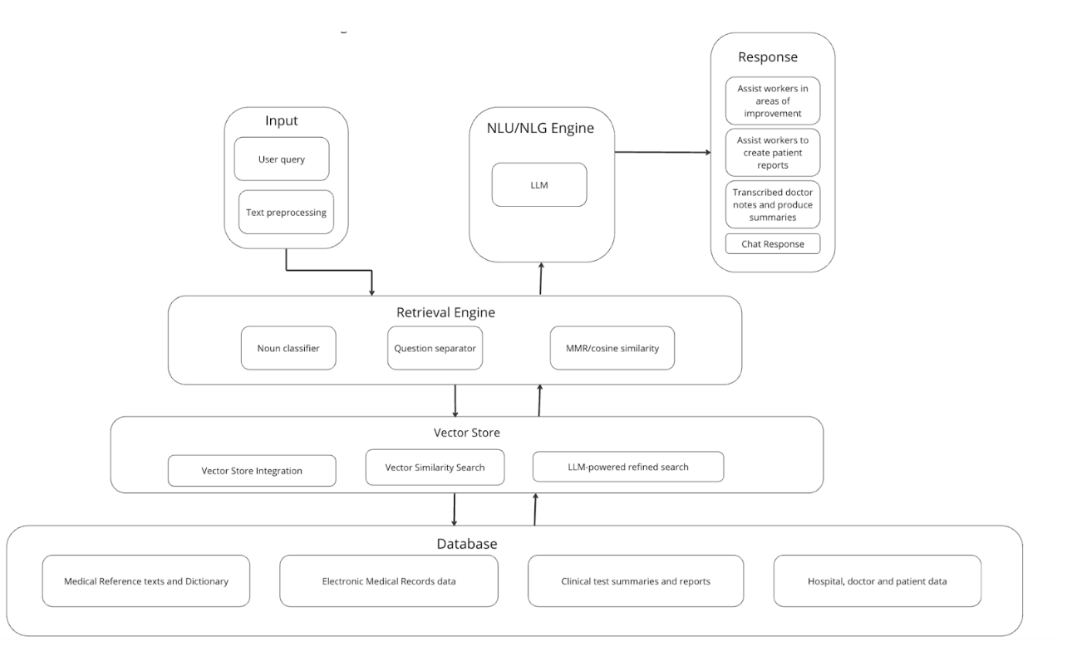

Conclusion
The proposed Financial Multi-Agent System offers a comprehensive approach to improving financial decision-making through AI-powered financial analysis, multi-agent collaboration, and real-time risk assessment. By integrating various financial data sources, the system significantly enhances market prediction, portfolio management, and trading strategies.
While challenges like data accuracy, model retraining, and real-time processing exist, the advantages of an AI-driven financial system provide a strategic edge in decision-making. The phased implementation approach will include pilot deployments, data validation, and iterative improvements to ensure scalability and successful adoption in financial operations.

